

The Impact of Pet Interaction on Stress Among Pet Owners

Research report submitted by:
Hamdha Mohamed Saheer (COADDS24.1F-018)
Rushdha Najath (COADDS24.1F-038)

Advanced Diploma in Data Science
National Innovation Centre
Colombo, Sri Lanka.
2025.03.17

Student’s Declarations
I hereby declare that the work presented in this project report was carried out independently by myself and have cited the work of others and given due reference diligently.
Rushdha Najath
Hamdha Saheer

Supervisor’s Certification
I certify that the above students carried out their project under my supervision and guidance.

Ms.J.B DonPaul
17.03.2025

Acknowledgment

We would like to express our gratitude to all those who have supported and guided us throughout this research. We are sincerely thankful to our lecturers, Mr.D.D.A.Arthanayake, Ms.Chamilanka Wanigasekara, Ms.J.B DonPaul. for their guidance and encouragement. We are truly grateful for their support.
We would like to give our sincere appreciation to respondents who helped us to gather data for this report.

TABLE OF CONTENTS
Chapter 01: INTRODUCTION
1.1 Background
1.2 Research Problem
1.3 Research Question
1.4 Objectives of the project
1.5 Scope of the research
1.6 Justification of the research
1.7 Limitations

Chapter 02: LITERATURE REVIEW
2.1 Introduction to the research theme
2.2 Theoretical explanation about the Key Words in the Topic
2.3 Findings by other researchers
2.4 The research gap
2.5 Table for Variables, their definition and sources
2.6 Chapter conclusion

Chapter 03: METHODOLOGY
3.1 Introduction
3.2 Population, Sample and Sampling technique
3.3 Type of Data to be collected and data sources
3.4 Data collection tools and plan
3.5 Conceptual framework
3.6 Hypothesis
3.7 Operationalization table
3.8 Methods of data analysis
Chapter 04: DATA ANALYSIS
4.1 Data Analysis
4.2 Finding and Interpretation

Chapter 05: DISCUSSION AND RECOMMENDATIONS
5.1 Discussion
5.2 Recommendation
5.3 Conclusion

REFERENCES

APPENDIX
Appendix A: Demographical Questionnaire
Appendix B: CCAS
Appendix C: PSS

LIST OF ABBREVIATIONS
CCAS: Comfort from Companion Animal Scale
PSS: Perceived Stress Scale

Chapter 01: INTRODUCTION
1.1 Background

Stress has become a pervasive issue for young adults in today's world due to various factors such as family, work, studies, financial concerns, and personal relationships. This stress can affect both physical and mental health and can also cause anxiety and depression.
studies have shown that interacting with animals can decrease levels of cortisol (a stress related hormone) and lower blood pressure (National Institutes of Health, 2018). This research aims to fill the gap by examining the relationship between stress and pet interaction by focusing on factors like type of pet, interaction frequency, daily care time, living environment, socio-demographic factors and finding the factors which effect pet owners' stress.

1.2 Research Problem
Stress is a common issue for individuals especially young adults, affecting their mental and emotional well-being. Various factors like lifestyle, academic, social environment and personal responsibilities causes stress among young adults. Pet interaction is considered as a potential factor in stress reduction among pet owners. However, to find what aspects of keeping pet such as pet type, interaction frequency, daily care time, pet friendly environment remains understudied in terms of their impact on stress levels. Pet owner's demographic factors (age, gender, living situation, employment status, marital status and income) may also influence perceived stress levels of pet owners. Furthermore, pet attachment which is measured by CCAS may also play a role in perceived stress level. This study aims to explore how these factors contribute to stress levels of young adults aged between 18-30 in Sri Lanka’s western province.
1.3 Research Question
- How do pet type, interaction frequency and daily care time influence the perceived stress level of pet owners among young adults in Western province, Sri Lanka?
- Is there a relationship between time spent on daily pet care and stress reduction among young adults in Western province, Sri Lanka?
- Does owners' demographic factors (age, gender, living situation, employment status, marital status and income) impact perceived stress levels among pet owners among young adults in Western province, Sri Lanka?
- Is there a significant association between pet attachment (CCAS) and perceived stress (PSS)

1.4 Objectives of the project
To analyse the impact of pet ownership characteristics (pet type, interaction frequency, daily care time, pet friendly environment), owner demographic factors (age, gender, living situation, employment status, marital status and income) and the Comfort from Companion Animals Scale (CCAS) on the perceived stress levels (PSS) among young pet owners in the Western Province of Sri Lanka .
1.5 Scope of the research
The scope of the research is limited to young adults aged 18 to 30 who are pet owners living within the Western Province, Sri Lanka. It does not cover adults who do not own a pet or those who are outside the specified age range.

1.6 Justification of the research
Focus on Sri Lanka’s Western province
Addressing factors that influence stress of pet owners

1.7 Limitations
Sample size: This study will focus on 137 young adults aged 18-30 in the Western province of Sri Lanka.
Self-reported Data: This study relies on self-reported data from surveys. So, participants might overstate or downplay their pet attachment and stress level questionnaire which could create bias into the results. This can impact the accuracy of findings.
Geographic: This study only focuses on young adults in the western province, the result may not be applicable to other demographic groups.
Stress measurement: Stress levels will be partially measured through Perceived stress scale (PSS), which relies on self-reported data.
Measuring Pet Attachment: The comfort from companion Animals Scale (CCAS) will be used to assess the level of attachment between pets and their owners.

Chapter 02: LITERATURE REVIEW

2.1 Introduction to the research theme
Pets have long served loyal and compassionate companions of humanity. The human-animal interaction and attachment hold a high potential to enhance mental health and well-being. (Sakshi Pandey, Vishal Yadav, 2024) This is followed by a discussion on pet attachment and perceived stress. The literature on the relationship between these variables has been considered. The purpose of a literature review is to improve the researcher’s own understanding of the variables surrounding the research questions, to ensure that the study will fill a gap in the current literature and inform the reader about the topic at hand. (Simonne Wright, 2018) This research examines pet interaction effect on pet owners’ stress, and focusing on variables such as pet type, pet attachment, perceived role of pet, pet care time, pet interaction frequency, degree of stress, and demographic characteristics. This study aims to find a comprehensive understanding of how pets reduce pet owners’ stress levels.

2.2 Theoretical explanation about the key words in the topic
Pets: A pet is an animal that a person chooses to take care of. They are either domesticated or tame and are kept for companionship rather than for utilitarian purposes (Simonne Wright, 2018). Animals that are usually kept as pets are Cat, Dog, Bird, Fish, Reptile and Rabbit.
Pet Owner: Pet owner is a term that defined an individual who maintains a caregiving relationship with a pet.
Pet Attachment: Pet attachment refers to a close, emotional bond between a human and an animal which provides emotional and physical support. (Simonne Wright, 2018) Attachment is at the centre of psychological benefits of having a pets because its intensity would measure how well-off and pampered pets will leave their owners.
Stress: Stress was defined as the individual-environment relationship that the person assessed as exceeding the available resources and that endangered their well-being. (Aliya Khalid, Saadia Dildar, 2019) In other words, perceived stress scales measures how stressful a person perceives in their life.

2.3 Findings by other researchers
Many studies indicate that pet owners have lower stress levels compared to non-pet owners. (Sakshi Pandey, Vishal Yadav (2024)). This is impute to be factors like companionship, social network enhancement, and the health benefits of pets.(Sakshi Pandey, Vishal Yadav (2024)).Pets can provide an emotional outlet and are often seen as responsive and non-judgemental listeners, which helps pet-owners confide and express their emotions(Sakshi Pandey, Vishal Yadav (2024)). A study evaluates stress reduction through pet interaction found that pet owners had lower scores on stress after associate with their pets compared to non-owners who interacted with pets (Aliya Khalid, Saadia Dildar (2019))
Interaction with pets, anyhow ownership, can lead to reduced stress level individuals (Aliya Khalid, Saadia Dildar (2019)). This provides that even pet owners can experience further stress reduction through direct engagement with pets. Interacting with a pet for more than five minutes was associated with lower stress scores compared to shorter interaction (Aliya Khalid, Saadia Dildar (2019))
Pet owners often think about their pets as part of the family and as attachment figures, which contributes to greater stress reduction. This bond provides emotional support like human relationship (Aliya Khalid, Saadia Dildar (2019)). Pets can role as better supportive figures than friends and spouses in certain stressful condition. (Aliya Khalid, Saadia Dildar (2019))

Research on South African adults founds no significant difference in perceived stress between pet owners and non-pet owners. (Simonne Wright (2018)) Another study on college student found no significant difference in stress levels between those daily dog interaction and those without (Mae Wells). A study on college students reported that participants who interacted with pets had statistically higher level of stress. (Chloe M. Guidry (December 5,2020))
While many studies shows that interaction with pets is beneficial for stress reduction among pet owners, the findings are not universally consistent. Factors such as type of pet, interaction frequency can influence the impact of pets on stress level.
2.4 The research gap
While there is evidence from international studies showing about pet interaction there is a lack of research on how pet interaction affects stress in developing countries like Sri Lanka. So, this research focuses on young adults aged 18 to 30 in Western province of Sri Lanka to explore the relationship between pet attachment and stress among pet owners.
2.5 Table of Variables, their definitions and sources
Variables | Definitions | Sources
Pet Type | The type of pet owned by owner (e.g., Dog, Cat, Bird, Reptile, etc.) | Simonne Wright (2018)
Perceive role of pet | How the owners views their pets | Cynthia Sau Ting Wu, Rosa Sze Man Wong, and Wing Hin Chu was published (2018)
Pet care time | The amount of time spent on pet care | Aliya Khalid, Saadia Dildar (2019)
Stress level | The degree of perceived stress experienced by pet owners. (PSS) | Simonne Wright (2018)
Pet Attachment | Emotional bond between Pet owner and their pets (CCAS) | Simonne Wright (2018)
Demographic | Information about the pet owners (e.g., Age, Gender, Family Income, Province, etc.) | Simonne Wright (2018), Aliya Khalid, Saadia Dildar (2019)
Pet interaction frequency | How often owner interact with their pet | Aliya Khalid, Saadia Dildar (2019)

2.6 Chapter conclusion
This chapter discussed the research theme, theoretical explanation about key words, findings, and the research gap. The relationship between these variables also considered.

Chapter 03: METHODOLOGY
3.1 Introduction
This chapter outlines the research methodology used in the study. This includes the population, sample, data collection, Conceptual framework, Operationalization table, hypothesis, and methods of analysis. It gives a clear direction for how the research objectives will be achieved.

3.2 Population, Sample, Sampling technique

Population: The study focuses on adults aged 18 to 30 residing in the Western Province of Sri lanka.the target population includes only pet owners who own various type of pets such as dogs, cats,rabbits and other companion animals.
Sample: A total of 130 pet owners aged 18-30 from the Western province of Sri Lanka.
Sampling technique: using convenience sampling method to collect data from 130 pet owners from western province of Sri Lanka by sharing the surveys through WhatsApp and Instagram.

3.3 Type of Data to be collected and data sources
Type of Data
Numeric data: CCAS scores (Q1 to Q13) and PSS scores(Q1 to Q10), owner’s age.
The primary measure of the stress will be the perceived stress scale (pss) score which will be calculated by participants responses to the PSS-10 questionnaire.
CCAS score this is also a Quantitative data used in this study and it is calculated by participants responses to the Comfort from companion animal (CCAS) questionnaire.
Categorical data: pet type, interaction frequency, daily care time, pet friendly environment, owner demographic factors (gender, living situation, employment status, marital status and income) and Western province.
- Gender: Categorical (e.g., Female, Male)
- Living Situation: Categorical (e.g., Living with partner, Living with family)
- Employment Status: Categorical (e.g., Student)
- Marital Status: Categorical (e.g., Unmarried)
- Family Income: Categorical (e.g., Below 50,000, 350,000 - 700,000)
- Western Province: Categorical (Yes/No)

Primary sources: The data collected from the pet owners through surveys.
Secondary sources: Published articles and research papers from research gate, google scholar

3.4 Data collection tools and plan
The data was collected Online using google form. The research data was anonymous. The link to the study was shared via social media platform using WhatsApp and Instagram. The data collection was anonymous maintaining the privacy of the participants.

3.5 Conceptual framework
Independent variables
- Pet type (Dog, cat, etc)
- Perceived role of the pet (family member, friend, working partner, toy)
- Interaction frequency (daily, weekly, monthly)
- Daily pet care time (0-15, 16-30, 31-60, 61-120, 121-180, >180)
- Pet friendly Environment (yes, no)
- Owner Demographics
- Owner gender (male, female)
- Owner living situation (living alone, living with family, living with roommate, living with partner)
- Owner employment status (student, employed full, employed part, unemployed)
- Owner marital status (unmarried, married)
- Owner family income (below 50000, 50000-150000, 150000-350000, 350000-700000, above 700000)
Dependent variable
- PSS score
- Stress level (low, moderate, high)
Hypothesized relationship
- Pet type → Stress score (PSS score)
- Perceived role of the pet → Stress score (PSS score)
- Interaction frequency → Stress score (PSS score)
- Daily pet care time → Stress score (PSS score)
- Pet friendly Environment → Stress score (PSS score)
- Owner Demographics → Stress score (PSS score)

3.6 Hypothesis
Objective 1
Null hypotheses Ho : There is no significant relationship between the independent variables pet type, interaction frequency, daily care time, pet friendly environment, owner demographic factors age, gender, living situation, employment status, marital status and income and the Comfort from Companion Animals Scale (CCAS) on the dependent variable perceived stress score.
Alternative hypotheses Ha : There is significant relationship between independent variables pet type, interaction frequency, daily care time, pet friendly environment, owner demographic factors age, gender, living situation, employment status, marital status and income and the Comfort from Companion Animals Scale (CCAS) on the dependent variable perceived stress score.

3.7 Operationalization Table
Variables | Definitions | Variable type | Measures | References
Pet Type | The type of pet owned by owner (e.g., Dog, Cat, Bird, Reptile, etc.) | Independent | Categorical | Simonne Wright (2018)
Perceive role of pet | How the owners views their pets | Independent | Categorical | Cynthia Sau Ting Wu, Rosa Sze Man Wong, and Wing Hin Chu was published (2018)
Pet care time | The amount of time spent on pet care | Independent | Ordinal | Simonne Wright (2018)
Stress score (PSS score) | Score from the perceived stress scale experienced by pet owners. (PSS) | dependent | Numerical(0-40) | Simonne Wright (2018)
Pet Attachment Score (CCAS score) | Sum score from CCAS scale between Pet owner and their pets | Independent | Numerical(Sum of scores from 13 item) | Simonne Wright (2018)
Demographic | Information about the pet owners (e.g., Age, Gender, Family Income, Province, etc.) | Independent | Categorical (Gender, Family Income, Province) and numerical (age) | Simonne Wright (2018)
Pet interaction frequency | How often owner interact with their pet | Independent | Categorical | Aliya Khalid, Saadia Dildar (2019)
Stress levels | The levels of stress experienced by the pet owner, categorized based on pss score. | Dependent | Ordinal (low, moderate, high) | Simonne Wright (2018)

3.8 Methods of data analysis

In this study for the hypotheses testing multiple linear regression analysis was conducted to understand the effects of various factors pet type, interaction frequency, daily care time, pet friendly environment, owner demographic factors age, gender, living situation, employment status, marital status and income and the Comfort from Companion Animals Scale (CCAS) on the perceived stress levels (PSS) scores. This regression model allows for to find whether the independent variables are significantly associated with pet owner’s stress score.

To find the levels of stress among pet owners this study finds the pss score and categorizing it into 3 groups
- Low stress (pss score 0-13)
- Moderate stress (pss score 14-26)
- High stress (pss score 27-40)

Chapter 04: DATA ANALYSIS
4.1 Data Analysis

A complete number of 137 participants completed the survey-based online questionnaire via Instagram and WhatsApp. Among the participants 52.2% of them were female and 47.8% were male.
Figure 4.1: gender distribution

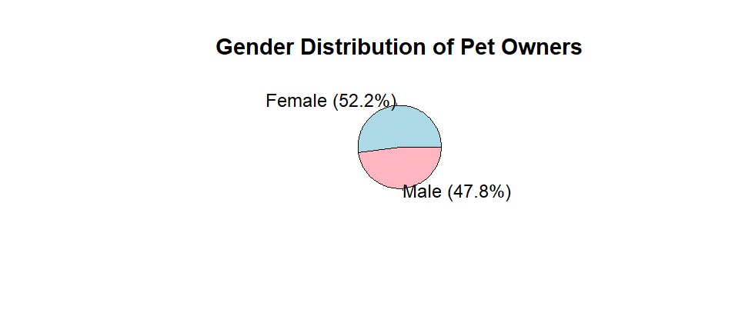
The histogram in figure 4.2 shows the distribution of participants ages in dataset. The majority of ages falls within our sample range aged 18-30. However, two data points are likely data entry errors or anomalies. To ensure the accuracy we are removing these two data.
Figure 4.2: distribution of pet owner's age
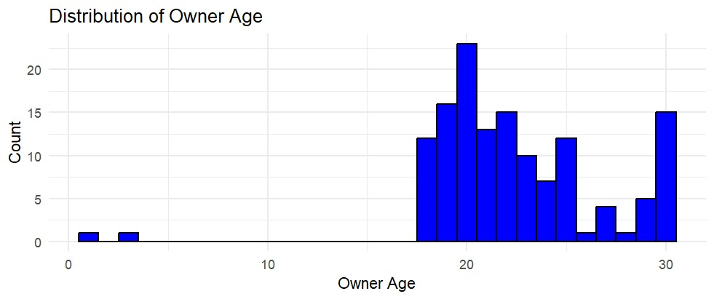

Through finding pss score for each participant and then categorize them into low, high, moderate stress. The histogram in figure 4.3 shows the distribution of stress levels. The analysis reveals that many pet owners in the sample are experiencing high level of stress.

Figure 4.3 : Distribution of stress levels
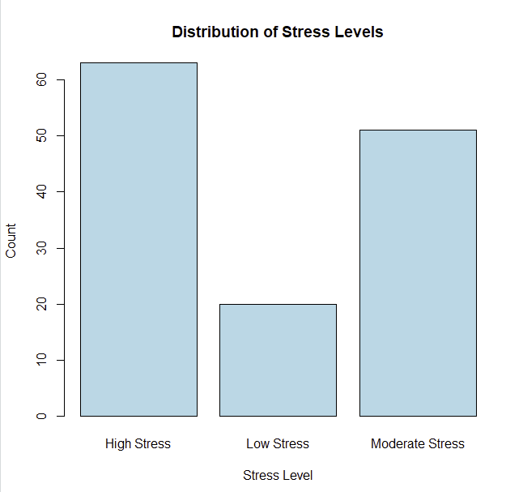

The analysis examines the relationship between the stress levels (PSS score) of pet owners and the independent variables such as pet type, interaction frequency, pet-friendly environment, daily pet care time, owner demographics and CCAS score. Table 1 presents the linear regression model that was applied to find which factors examines the stress levels of pet owners.

Table 1
Multiple linear Regression analysis
Coefficients:
Estimate Std. Error t value Pr(>|t|)
(Intercept) 38.7419 12.3369 3.140 0.00278 **
pet.typeCat -6.8049 4.7326 -1.438 0.15646
pet.typeDog -1.5352 5.4520 -0.282 0.77938
pet.typeFish 0.1944 8.8799 0.022 0.98262
pet.typeGoat 8.6685 10.9889 0.789 0.43378
pet.typeHens 4.7360 10.5349 0.450 0.65490
pet.typeRabbit 7.6552 10.4238 0.734 0.46601
pet.typeSquirrel -5.5341 8.7172 -0.635 0.52831
Interaction.frequencyMonthly -1.3942 11.3609 -0.123 0.90280
Interaction.frequencyWeekly -1.3009 3.9351 -0.331 0.74229
pet.friendly.environmentYes -0.7095 3.6959 -0.192 0.84851
daily.pet.care.time.minutes.0-15 -9.1046 5.1223 -1.777 0.08134 .
daily.pet.care.time.minutes.121-180 -1.5318 4.4090 -0.347 0.72967
daily.pet.care.time.minutes.16-30 -6.3176 3.9785 -1.588 0.11836
daily.pet.care.time.minutes.31-60 -10.5878 4.5806 -2.311 0.02480 *
daily.pet.care.time.minutes.61-120 -4.8330 4.2824 -1.129 0.26427
owner.genderMale 0.0627 2.6634 0.024 0.98131
owner.living.situationLiving with family -2.4624 4.5938 -0.536 0.59422
owner.living.situationLiving with partner 1.6556 8.0134 0.207 0.83713
owner.living.situationLiving with roommate 0.8165 8.3898 0.097 0.92284
owner.employment.statusEmployed(part) 7.1353 8.1521 0.875 0.38545
owner.employment.statusStudent 3.7025 5.3546 0.691 0.49235
owner.employment.statusStudent, Employed(full) 3.5067 14.5988 0.240 0.81111
owner.employment.statusStudent, Employed(part) 13.6059 7.1871 1.893 0.06391 .
owner.employment.statusUnEmployed 6.0684 5.6924 1.066 0.29133
owner.martial.statusunmarried 0.8470 4.7030 0.180 0.85777
owner.family.incomeBelow 50,000 2.5549 6.7742 0.377 0.70759
owner.family.income150,000 \x96 350,000 1.7739 6.1754 0.287 0.77506
owner.family.income50,000 \x96 150,000 4.1194 6.1087 0.674 0.50308
owner.family.income350,000 \x96 700,000 3.8512 6.4486 0.597 0.55295
CCAS_SCORE -0.2087 0.1843 -1.132 0.26281
The regression analysis revealed that daily pet care time had a significant effect, with owners spending 31-60 minutes on pet care showing lower PSS scores (B = -10.59, p = 0.0248 [<0.05]). The 0-15 minutes category also showed a marginal association (B = -9.10, p = 0.0813 [>0.05]). However, pet type was not significantly related to the outcome, as all categories had high p-values, including cats (B = -6.80, p = 0.1565 [>0.05]), dogs (B = -1.54, p = 0.7794 [>0.05]), and fish (B = 0.19, p = 0.9826 [>0.05]). Similarly, interaction frequency (monthly: B = -1.39, p = 0.9028 [>0.05]; weekly: B = -1.30, p = 0.7423 [>0.05]) and pet-friendly environment (B = -0.71, p = 0.8485 [>0.05]) were not significant predictors. Among demographic variables, gender (B = 0.06, p = 0.9813 [>0.05]), living situation (e.g., living with family: B = -2.46, p = 0.5942 [>0.05]), employment status (e.g., student: B = 3.70, p = 0.4924 [>0.05]), and family income (e.g., below 50,000: B = 2.55, p = 0.7076 [>0.05]) showed no significant effects. Lastly, CCAS_SCORE had a negative relationship with the dependent variable (B = -0.21, p = 0.2628 [>0.05]), but this effect was not statistically significant. Overall, the model had a low explanatory power (F = 1.064, p = 0.4132 [>0.05]), indicating that most predictors were not significantly associated with the outcome.

4.2 Findings and Interpretation
The multiple linear regression conduct in this study examines the relationship between the independent variables like various pet related and demographic factors with the dependent variable stress level (PSS score). The predictors did not explain much variance in the dependent variable (PSS score).
Significant findings
1.Daily pet care time
Owners who spent 31-60 minutes per day on pet care showed a significant lower stress score (p=0.0248[<0.05]). This shows that moderate daily pet care has a stress relief benefit from pet care among pet owners.

2. pet type and interaction frequency
None of the pet types (cats, dogs, fish, rabbits, etc) had a significant effect. Interaction frequency (daily, weekly, monthly) did not significantly influence the stress levels (p>0.05).
These finding suggest that type of pet and frequency of interaction do not impact stress among pet owners.

3.Demographic variables
Owner’s gender, living situation, employment status, marital status and income levels shows no significant effects on stress score. So demographic variables does not predict the stress among pet owners.

4.CCAS score
The comfort from companion animal score (CCAS) also shows no significant effects on stress score (p=0.2628[.0.05]). So this pet attachment also does not predict the stress score among pet owners.

Interpretation
These findings suggest that daily pet care time influence the stress level of pet owners who particularly spend 31-60 minutes per day. However, the other factors such as pet type, interaction frequency, pet attachment score (CCAS score), demographic factors (owner’s gender, living situation, employment status, marital status and income levels) does not impact the stress on pet owners.

Chapter 05: DISCUSSION AND RECOMMENDATION
5.1 Discussion
In the previous chapter multiple linear regression which was conducted in this study showed among pet-related factors, owner demographics, CCAS score which effects perceived stress score of pet owners. Key finding include:
Daily pet care time was the only significant predictor which predicts the stress level of pet owners. Owners who spent 31-60 minutes per day on pet care had significantly lower stress scores. Pet type and interaction frequency, Demographic variables, Pet attachment these factors did not show statistically significant effect on perceived stress.
So, from the study daily pet care time (31-60 minutes) was found to be a significant stress reducing factor. However, the other factors pet type, interaction frequency, owners' demographics and CCAS scores did not show significant associations.
Pet interaction frequency helps in stress reduction (wright, 2018), but this study did not show such effect it could be due to individual differences and the sample size. Some previous studies show a strong link between pet attachment and stress score (khalid & dildar, 2019) but this study did not observe a significant effect. It may be because of attachment styles. Additionally, the homogenity of the study (young adults in Sri Lanka's western province) might have led to non-significant results.

5.2 Recommendations
Future research directions
- Future research should focus on long term effects of pet interaction and attachment on stress using repeated measures.
- Expanding research beyond young adults and western province. This will enhance generalizability.
- Research should focus why pet care reduces stress and whether specific pet behaviours contribute stress.
- Providing an option for people who own more than one pet.

5.3 Conclusions
This current study examines the impact of pet interaction factors, demographic factors on stress levels among young adults in Sri Lanka’s western province. The key finding tells that moderate daily pet care time (31-60 minutes) is associated with lower stress while the other factors like pet type, interaction frequency and owner demographics did not show significant effects.
While these findings shows pet related stress reduction factors and the factors which does not influence stress of pet owners, further research is needed to explore more mechanisms and improve methodological approaches.

REFERENCES
Simonne Wright (2018) ‘The relationship between pet attachment, perceived stress and life satisfaction: An online survey’ [online]. Available from https://scholar.sun.ac.za/items/c1dd5912-a7dd-4d26-b7ca-6829275585df [March 2018]
Sakshi Pandey, Vishal Yadav (2024) ‘A Comparative Study of stress Between Pet Owners and Non-Pet Owners’ [online]. Available from https://ijip.in/wp-content/uploads/2024/02/18.01.101.20241201.pdf [ 2024]
Aliya Khalid, Saadia Dildar (2019) ‘Effect of Pet Interaction on Stress Reduction and Positive Mood Enhancement among Pet-Owners and Non-Owners' [online]. Available from https://www.researchgate.net/publication/331971468_Effect_of_pet_interaction_on_stress_reduction_and_positive_mood_enhancement_among_pet-owners_and_non-owners [2019]
Devarajan. R, Jayanthe. R, Kosala. W (2022) ‘“In times of stress, it is good to be with them”: experience of dog owners from a rural district of Sri Lanka’ [online]. Available from https://doi.org/10.1186/s12889-022-14863-6 [2022]
Lee Zasloff (23. July.2015) ‘Measuring attachment to companion animals: a dog is not a cat is not a bird’[online]. available from https://www.researchgate.net/publication/222247969 [23 July 2015)
Kristen C, Jacobson, Laura Chang (2018) ‘Association Between Pet Ownership and Attitudes Toward Pets with Youth Socioemotional Outcomes’ [online]. available from https://pubmed.ncbi.nlm.nih.gov/30534102/ [ 26 November 2018]
Roxanne D, Hawkins, Chin-Hsin Kuo, Charlotte.R, (2024) ‘Young adults’ views on the mechanism underpinning the impact of pets on symptoms of anxiety and depression’[online]. available from https://www.ncbi.nlm.nih.gov/pmc/articles/PMC10902138/ [15 February 2024]
Catarina F. Martins, Jorge P. Soares, Antonio .C, Luis. S, Luis. C, Maria A. Pires, maria P. Mota (2023) ‘Pet’s influence on humans’ daily physical activity and mental health: a meta-analysis' [online]. available from https://www.ncbi.nlm.nih.gov/pmc/articles/PMC10262044/ [30 May 2023]
Chloe M. Guidry (December 5,2020) ‘Pets and Stress: Does interaction with pets correlate with stress levels?’[online]. available from https://www.researchgate.net/publication/379542280 [04 April 2024]
Christy George Eapen, Febin George Jacob (2023) ‘Pet and Well-Being: A Study among Young Adults’[online]. Available from https://ijrpr.com/uploads/V4ISSUE1/IJRPR9300.pdf [January 2023]
Mae Wells. ‘The Effect of Pet Ownership on College Students’ Stress Levels’ [online]. Available from https://www.mckendree.edu/academics/scholars/wells-issue-29.pdf
Cynthia Sau Ting Wu, Rosa Sze Man Wong, Wing (2018) ‘The association of pet ownership and attachment with perceived among Chinese adults’[online]. Available from https://www.tandfonline.com/doi/full/10.1080/08927936.2018.1505269 [19.sep.2018]

APPENDIX
Appendix A: Demographic Questionnaire
Which type of pet do you own?
Dog
Cat
Bird
Cow
Reptile
Fish
Rabbit

Perceived role of the pet
Family Member
Friend
Working Partner
Toy

How often do owners interact with their pets?
Daily
Weekly
Monthly

Daily time spent on pet care (minutes)
0-15
16-30
31-60
61-120
121-180
>180

Do you live in pet- friendly environment? (e.g., home with yard, pet-allowed apartment)
Yes
No

Pet owner’s age (e.g.,20)

Your answer

Pet owners’ gender
Male
Female
Prefer not to say

Your living situation
Living alone
Living with family
Living with roommate
Living with partner

Employment Status
Student
Employed (full)
Employed (part)
Unemployed

Marital status
Unmarried
Married

What is your family’s approximate monthly income range (in LKR) as a pet owner?
Below 50,000
50,000-150,000
150,000- 350,000
350,000- 700,000
Above 700,000

Are you residing in the western province area?
Yes
No

Appendix B: CCAS
The Comfort from Companion Animals Scale (CCAS) measures the emotional support and comfort provided by pets.
(1) Strongly Disagree, (2) Disagree, (3) Agree, (4) Strongly Agree

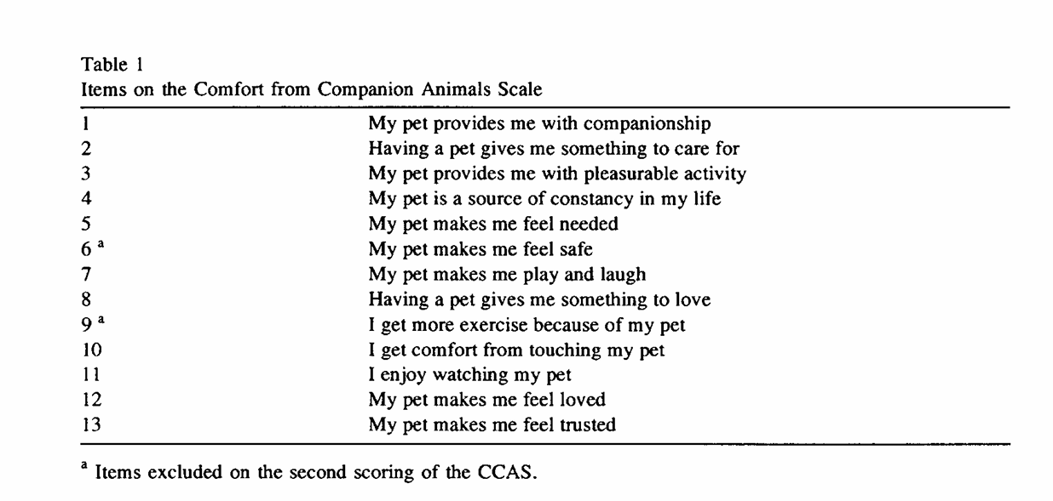

Appendix C: PSS
Perceived Stress Scale (PSS): Assesses your current stress levels.

